In this booklet you will be able to design your dream holiday!
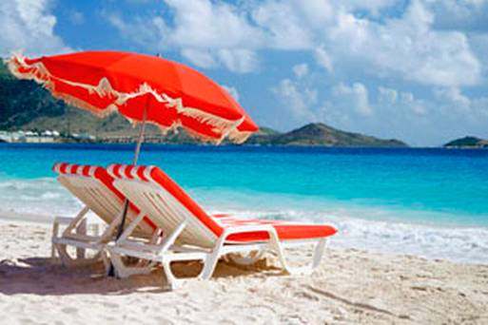
You can pick every single detail of your holiday so let your imagination go wild!
First of all we need to decide on a holiday location!
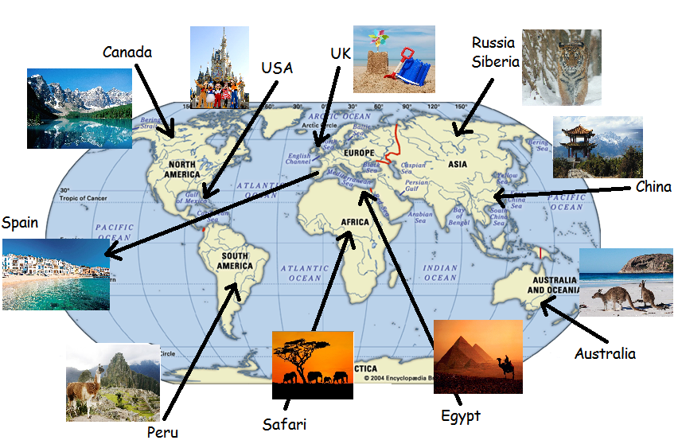
There are so many places in the world to pick from that I have made a few suggestions to help you decide.
My location is:
Describe your location. Make sure you include weather, possible activities (places to visit, animals to see), and the geography of the country (is it by the sea, mountainous etc).
Now we must know how you will travel to your chosen destination!
Aeroplane | Cruise Ship
 | 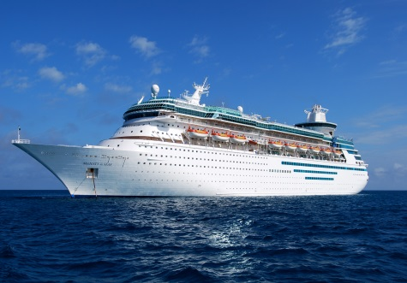
Train | Car
 | 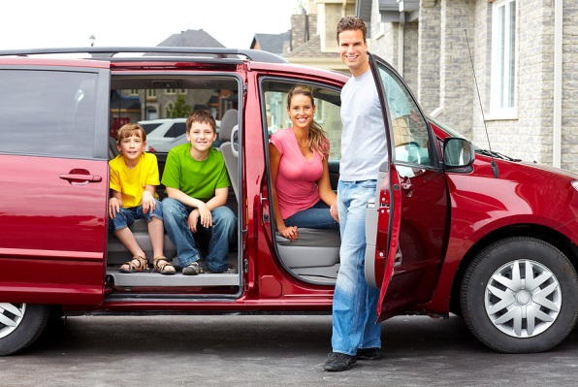
Remember a train can only link you to the UK and France and a car will get you to anywhere in Europe but no further.
My chosen method of transport will be:
Describe what your journey will be like. Remember to include all of the things you will do on your journey. Will you make any stops along the way?:
You now need to make sure you have the perfect place to stay.
Resort | Motel | Villa
 | 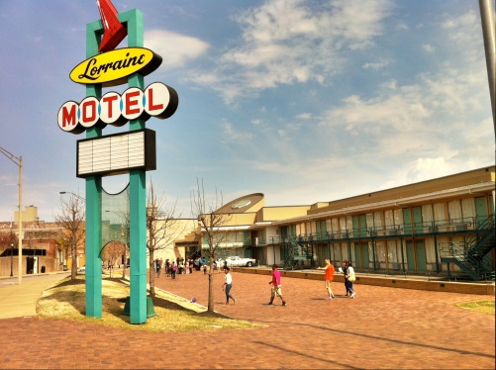 | 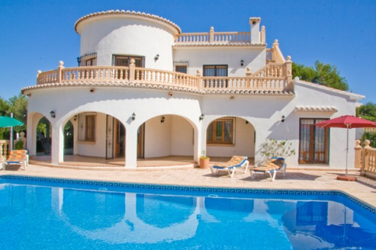
Tent | Caravan | Boat
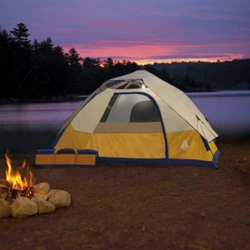 |  | 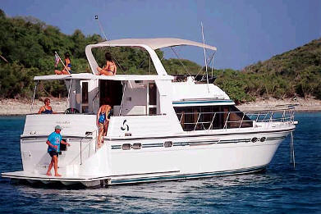
Remember that if you are staying in a boat you will need to be near water.
My chosen place to stay is:
Describe your perfect holiday home. Don’t forget to include what is inside and outside the holiday home:
Now we must make sure that we have everything we need in our suitcase.
Draw your items and label them with a reason for including each one.
(Complete your writing below if you would like more space.)
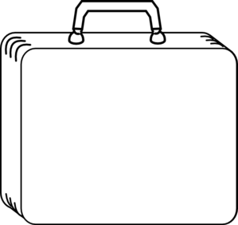

Going on holiday is the perfect time to try lots of different foods.
Design your perfect holiday meal below. Don’t forget to label everything.
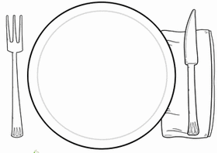
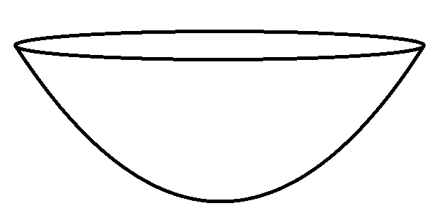
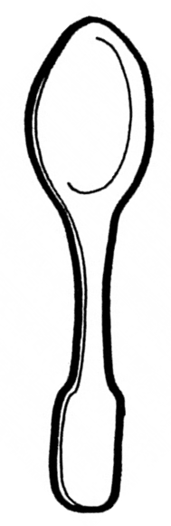
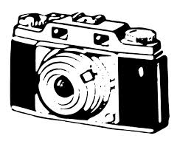
Now going on holiday requires a lot of taking photos! Draw some of your holiday snaps below!
